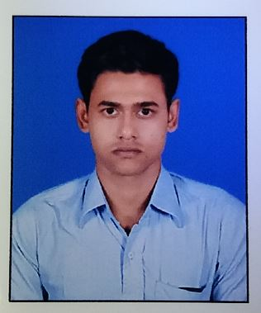

SUMANTA KOLEY

Siddheswar * Howrah

sumantakoley92@gmail.com* Ph: +919831204268
Career Objective:
I am hardworking and responsible person. And I am capable of performing my assigned duty, to the best of my ability, within given time, both individually and as a team member.

Professional Qualification:
Completed diploma in Electronics & Telecommunication Engineering under the council of West Bengal State Council of Technical Education from Santiniketan Institute of Polytechnic (Bolpur, Birbhum) from 2011 to 2014.

Academic Qualification:
Examination | Board | Institute | Percentage | Year of Passing
Secondary | WBBSE | Siddheswar Shankar Pathshala, Howrah | 68 | 2008
Higher Secondary | WBCHSE | Ekabbarpur Gobinda Panja High School, Howrah | 62 | 2010

Experience:
Company : HCL Infosystems Ltd
Role : Associate Customer Engineer
Responsibility : Project Maintaining
Skills : Desktop, Laptop, Server, Network, Windows, Linux
Duration : Two Years

Industrial Training:
Conducting Authority | Subject | Venue | Duration | Year
Youth Service – Govt. of West Bengal | Diploma in Information Technology Applications | Howrah | 1 Year | 2010
Webel – SRNH IT Academy | Hardware & Networking | Kolkata | 1 Month | 2012
National Council for Vocational Training | Basic Electronics | Bolpur | 1 Month | 2014

Others Qualification:
Particular | Under of | Place | Duration | Year
Painting | Bangiya Sangeet Parished, Rabindra Bharati University | Howrah | 5 Years | 2008
NCC | Fort William, Kolkata | Kolkata | 1 Year | 2009

Personal Details:
Date of Birth : 14th December 1992
Father’s name : Sukumar Koley
Mother’s name : Krishna Koley
Address (Home) : Siddheswar, Jagatballavpur, Howrah, West Bengal-711414, India
Passport No : M0567132
Religion : Hindu
Nationality : Indian
Gender : Male
Language known : English, Bengali & Hindi
Hobby : Adventure Stories, Painting

Declaration:
I do hereby declare that the particulars furnished by me above are correct to the best of my knowledge and belief.

Date: 15-07-2016
Place: Howrah, West Bengal 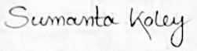
---------------------------------------
(Sumanta Koley)

